**Deep Transfer Learning CNN based approach for COVID-19 Detection**

Wazir Muhammad1,*Syed Ali Raza Sha, h2, Zuhaibuddin Bhutto3, Jalal Shah3, Murtaza Hussain Shaikh5, Ayaz Hussain1, Imdadullah Taheem2, Shamshad Ali1.

*1Department of Electrical Engineering, Balochistan University of Engineering & Technology, Khuzdar, Pakistan*

*2Department of Mechanical Engineering, Balochistan University of Engineering & Technology, Khuzdar, Pakistan*

*3Department of Computer System Engineering, Balochistan University of Engineering & Technology, Khuzdar, Pakistan*

*4Department of Department of Information Systems, Kyungsung University, Busan, South Korea*

|  |
| --- |
| ABSTRACT  The urge for medical diagnosis, testing, and effective treatment has drastically increased with the emergence of the global pandemic of COVID-19. Reverse transcription-polymerase chain reaction (RT-PCR) is considered to be the reliable test for the detection of COVID-19 which is time consuming and costly. However, the disease close relevancy to pneumonia provides the privilege of adopting other fast and economical approaches which include X-ray radiography of the chest for the detection of virus. These Chest X-Ray (CXR) images can be incorporated with modern machine learning techniques for quick and convenient diagnosis. This study integrates five different pre-trained models to enhance COVID-19 detection using a deep transfer learning approach. We evaluated our model in terms of classification rate, precision, sensitivity, and F1 score. Our proposed transfer learning model has shown an absolute precision for three out of five models in detecting the infection. The results provide an evidence that deep learning can be used for the detection forCOVID-19. We believe, this work will help for medical specialists to automatically evaluate the initial screening of suspicious COVID patients.  *Keywords:* COVID-19, Deep learning, Transfer Learning, COVID-19, Chest X-ray. |

**1. Introduction**

The Coronavirus disease endures by the presence of acute syndrome coronavirus 2 (SARS-CoV-2) first emerged in 2019 (COVID-2019) at Wuhan, China which has disperse to the other countries with a commute of infected people [1] and within no time, this disease has taken the shape of a global pandemic. The number of reported cases has reached 25 million as per early September2020 with more than 0.86 million deaths worldwide because of the COVID-19. World Health Organization (WHO) terms the formal name of this virus to be coronavirus disease (COVID-19), initially called “2019 novel coronavirus” [2]. The symptoms of COVID-19 include runny nose, fever, headache, and cough [3]. This virus has caused deaths in people particularly with a weak immune system [4]. It has caused serious implications on our daily life. The rapid increase in the number of cases leads to the urgency of fast diagnosis, effective testing, and enduring treatment. To control the spread of disease, there is a need for fast diagnosis with accuracy so that people carrying COVID can be isolated in time, thus the spread can be slowed down. Presently, the detection of COVID-19 in the medical field is attained by reverse transcription-polymerase chain reaction (RT-PCR) based testing which is recommended as an effective diagnostic approach till now. However, there are some fallbacks that include the limited sensitivity and scarcity in the availability of testing kits in the pandemic region (especially in developing countries) which has not only proved to be burdensome for the medical staff but also ignites the spread of the disease.

Recent research in the radiological field shows that computed tomography (CT) can be applied for the diagnosis of COVID-19 due to its high sensitivity and accuracy as compared to RT-PCR. The COVID-19 affects the lungs like pneumonia but induce lesions in the bilateral lung which is composed of ground-glass opacities (GGO), which has highlighted the significance of Chest X-ray(CXR) images or CT images for the identification of COVID-19. CT scan provides a convenient and economical solution as a diagnostic tool that is fast and reliable, thus presenting an alternative for RT-PCR. The diagnostic model can become more effective and reliable when incorporated with modern techniques of artificial intelligence and machine learning, thus preventing human error, and generating massive results within no time considering the pandemic situation.

The rest of the paper is organized as follows. Section 2 gives a brief introduction to Deep Learning-based Convolutional Neural Networks. Section 3 discuss about the proposed transfer learning model. Experimental results are presented in Section 4 and finally the paper is concluded in Section 5.

**RELATED WORK**

The World Health Organization (WHO) announced in February 2020 that a new virus known as COVID-19 had begun to spread quickly in various countries. COVID-19 is usually diagnosed because of pneumonia-like symptoms, which can be detected through genetic and imaging studies. Deep learning-based convolutional neural networks (CNNs) has significant applications in various field such as image super-resolution, satellite imaging, security surveillance and medical image classification tasks [5-11]. Promising results of deep learning in the field of medical diagnosis has urged the scientists to use it for COVID-19 detection as well. For, instance, some researchers have deployed a deep convolutional neural network technique to perceive the indication of COVID-19. Sethy et al., [12] deployed a novel methodology for discontenting and categorizing pneumonia infection from X-ray images. The primarily trained models are incorporated to retrieve the characteristics form X-ray images. Internet resources are used for the preparation of the dataset [13]. The features obtained from ResNet50 [14] with support vector machine (SVM) classifier [15] produce reliable results. Wang et al. introduces a model of deep learning-based CNN for corona virus detection which they call as COVID-NET [16]. In the proposed model, authors randomly select a medical image for COVID-19 detection and achieved 85.2% accuracy with 0.83 specificity and 0.67 of sensitivity. A model of VB-Net deep learning is proposed by Shan et al. which integrates to segment the infection regions of COVID-19 patients within CT scan images [17]. The training dataset used the images of 549 with different scenarios of disease obtained from different sources. The achieved accuracy is up to 91.6%. Hemdanet al. presented 7 different deep neural network architectures for COVID-19 classification. In their experimental work, they used 50 images of datasets and divided them into two categories, one is COVID-19 and other is non-COVID-19 [18]. The reported results are better with VGG19 [19] and DenseNet201 [20] models. Stephen et al. proposed a model that detects and classifies the cases of pneumonia [21]. The training dataset depends on the collection of chest X-ray images [22]. The experimental results report 2.88% training loss, 95.31% training accuracy, validation loss is 18.35% and validation accuracy is 93.73%. In [23], the authors used five pre-trained convolutional neural network models, VGG16 Network architecture [19] , ResNet50 [14], DenseNet-121 [20], DenseNet-169 and Xception Network architecture to extract the features. The pre-trained networks are used as a feature extractor followed by a different type of classifier which encloses Random Forest, K-nearest neighbor, Naıve Bayes, and SVM incorporated for the identification of pneumonia from X-ray images. In [24], the transfer learning technique has been deployed for the identification of COVID-19. They utilized an initially trained model of Inception-v3 [25] and ResNet50. Experimental results showed that ResNet50model presented the best results when compared to Inception-v3.

In [26], the authors proposed a medical image-based deep learning neural network architecture. In this study authors split dataset into three groups depending upon classification and nature which include a normal, pneumonia, and COVID-19 dataset. During their study, they have integrated five primarily trained models, and accomplish accuracy up to 98.75% for the binary categorization task. Ghoshal et al. [27] designed a deep model with four groups which include normal cases with no symptoms, pneumonia caused by bacteria, non-COVID-19 vigorous spreadable pneumonia and COVID-19. Zhang et al. [28] introduced a model which is based on anomaly detection for COVID-19 and achieved excellent performance in terms of specificity (87.84%) and sensitivity (90.00%). Ayan et al. [29], proposed the Xception [30] and VGG16 [19] based deep convolutional neural network models which are based on Pneumonia chest X-ray images. In their work, a dataset containing nearly around 5800 chest X-ray images are retrieved from the Kermany et al. [22]. Their approach classifies 4200 images as a pneumonia and remaining images as a pneumonia free case. The investigational results for VGG-16 network architecture reports 85% sensitivity, and 86% precision.

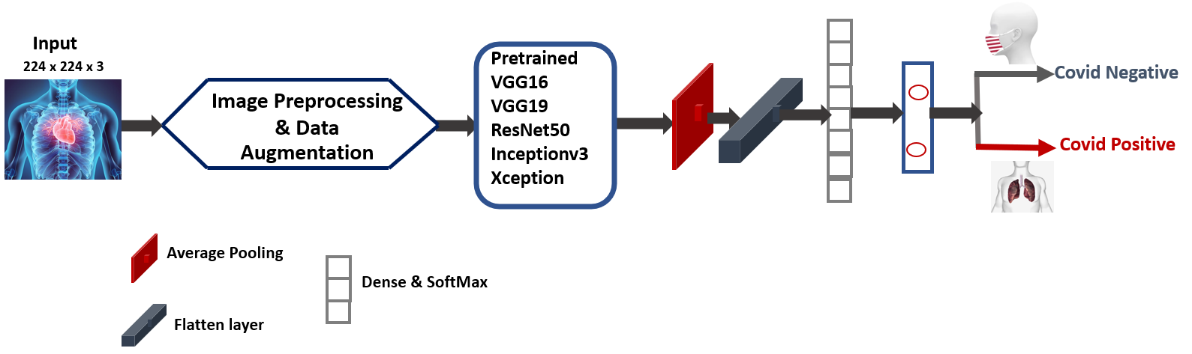

**Fig. 1:** Proposed designed for COVID-19 detection and classification

**Proposed Transfer Learning Model**

The design and development of a new model based on CNN is a complex, and time-consuming task. Integrating primarily trained models is a quick and efficient method to be adopted as compared to the consideration of developing a new CNN model [31]. In this work authors are proposed a new transfer learning type model that integrates a deep CNN framework for the identification of the COVID status through the X-ray images. Figure 1 presents an overall network architecture of proposed method and integrates a five initially trained deep CNN architectures; namely VGG16, VGG19, ResNet50, Inceptionv3, and Xception with the addition of three layers. The first layer is the average pooling layer and the other two are dense layers followed by ReLU and Softmax activation function. The last layer of each pretrained model is removed and replaced by the trainable part which consist of a fully connected/dense layer with dropout is 0.5. for binary classification purpose. This layer having 2 units with sigmoid output to classify the output of COVID-19 as Positive or Negative Class. Some characteristics of initially trained models are demonstrated in Table 1.

**Table 1:** Overall summary of pre-trained deep CNN models used with our approach

|  |  |  |  |  |  |
| --- | --- | --- | --- | --- | --- |
| Pre-trained Model | Input Size | Size (MB) | No: of  Parameters (M) | Top-1 Accuracy | Top-5 Accuracy |
| VGG16 | 224 × 224 × 3 | 528 | 138 | 0.713 | 0.901 |
| VGG19 | 224 × 224 × 3 | 549 | 143 | 0.713 | 0.900 |
| ResNet50 | 224 × 224 × 3 | 98 | 25 | 0.749 | 0.921 |
| Inceptionv3 | 299 × 299 × 3 | 92 | 23 | 0.779 | 0.937 |
| Xception | 299 × 299 × 3 | 88 | 22 | 0.790 | 0.945 |

**3.1. VGG16 AND VGG19**

VGG16 and VGG19 [19] is a deep CNN type network architecture proposed by K. Simonyan et.al, and can be successfully trained on the ImageNet dataset [32] consists of 14 million images belongs to 1000 different type of classes. In the ILSVRC-2014, [33] the model achieves 92.7% top-5 test accuracy. It replaces the large kernel size of AlexNet [34] with 3x3 filters. The training time of VGG16 and VGG19 is completed in weeks and the NVIDIA Titan GPU’s has been utilized. The network depth of VGG16 and VGG19 has a 16 and 19 layers.

3.2. **ResNet50**

ResNet50 [14] is a deep convolutional neural type network that depends on 50 number of deep layers. ResNet50 is trained on more than one million images obtained from the database of ImageNet [32]. The model can classify different images into 1000 categories, such as animals, pencils, mouse, and keyboards. The input size of the pre-trained network is 224-by-224.

3.3. **Inceptionv3**

Inceptionv3 [25] is a deep CNN network that has 48 deep CNN layers. Inceptionv3 model is also trained on ImageNet database [32]. The pre-trained model can classify the images into different 1000 types of subcategories, like animals, keyboard, pencil, and mouse. Millions of images provide rich feature representations. The input size of the image in the network is 299-by-299.

3.4. **Xception**

In 2017, Google introduced the new architecture named Xception network [30], which stands for the extreme version of an Inception. In this architecture, standard convolution operation is replaced by depth-wise separable convolution, which is better than Inceptionv3. Xception model is trained on ImageNet dataset as well as on the JFT dataset [35]. Xception network achieves 0.790 Top1-accuracy and 0.945 Top-5 accuracy. The input size of the image in the network is 299-by-299.

**EXPERIMENTAL RESULTS**

The proposed transfer learning type model is designed in Python 3.7 using deep learning library Keras backend as a TensorFlow. All experimental results are conducted on the computer of the Intel Xeon processor (2 GHz) with RAM of 96 GB. All pre-trained model weights are updated with the mini-batch size is 32 and the initial learning rate is 0.0003. The proposed model has been tested in the two classes, such as COVID-19 Positive and COVID-19 Negative class.

**4.1. Collection of Data**

For the experimental procedure and assessment, we have deployed two categories of image sets which enclose COVID-Negative and COVID-Positive. Since COVID-19 is a new research area, therefore the number of images related to COVID-19 is still limited. To overcome this limitation, we combine two available datasets that are publicly accessible consisting of COVID-19(COVID-Positive) and normal images with no COVID generally named as COVID-Negative. The said dataset for COVID-19 X-ray images is openly made available by Cohen JP [37]. The authors gathered the images from different open access sources. Next dataset of COVID-19 images is developed by a medical doctors’ teams from Bangladesh and Qatar University [36]. The recent version of the COVID-19 image dataset having more than two hundred X-ray images is accessible from Kaggle website. In the training phase, dataset of 200 COVID-Negative images and 230 of COVID-Positive images are considered. In the test dataset, COVID-Negative is 150 number of images and 203 is the COVID-Positive images.

**4.2. Data Augmentation**

While classifying both traditional as well as deep learning approaches, the training dataset has an important role in determining the performance of the model. In order to enhance the performance and to overcome the issue of over-fitting, we have used data augmentation techniques in the form of rotation, flipping, and shearing as shown in Fig 2.

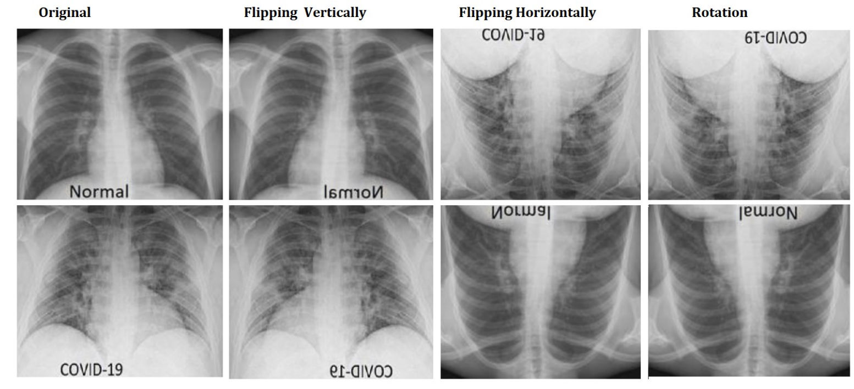

**Fig. 2:** Data augmentation on the original image.

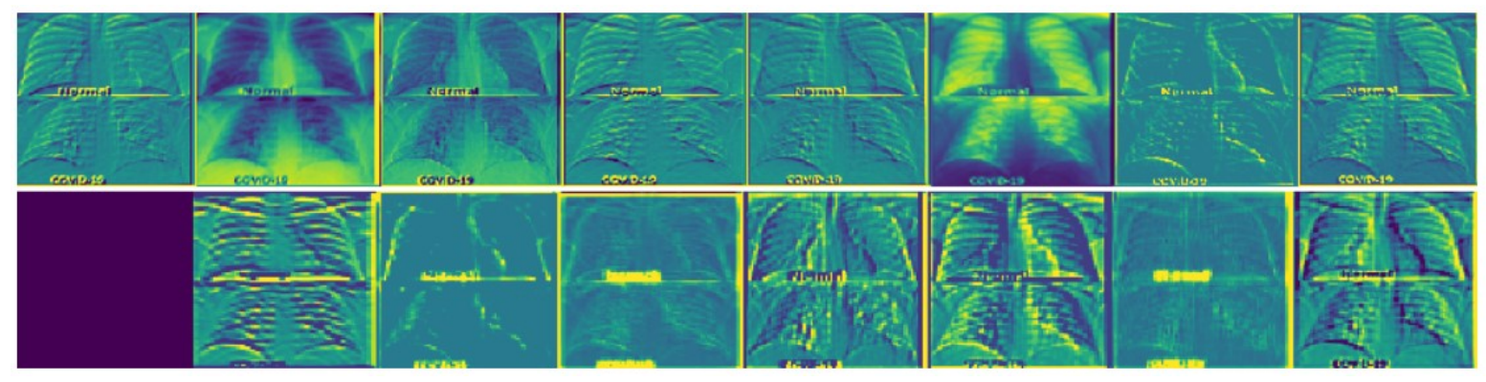

**Fig. 3:** Feature Activation map of different layers

**4.3. Feature Map Visualization of COVID-19 Image in the Layers**

In Fig. 3, we analyzed the segment of the image for which the CNN by complementing the segments in the original images. The values in the activation maps can be normalized between the range of 0 and 1, in case they have different range.

**4.4. Performance Evaluation Metrices**

There are many types of performance evaluation metrics available in the literature, but here we consider confusion matrix to evaluate the effectiveness and performance assessment of the proposed models.

**4.4.1. Confusion Matrix**

In predictive type analysis, a confusion matrix, also termed as a table of con-fusion, have two rows and two columns that identify the number of a false positive, false negative, true positive, and true negative [37]. A True Positive (TP) is an outcome where the model predicts correctly as a positive class. A True Negative (TN) is an outcome where the model predicts correctly as a negative class. A False Positive, also termed as Type I error, occurs in results where the presented model makes the wrong forecast regarding the existence of positive class. A False Negative is also categorized as a Type II error generated in the results which invokes wrong predictions regarding the negative class.

In Fig. 4, the confusion matrices of two classes, such as COVID-Positive and COVID-Negative test results on 5 pretrained transfer learning models are given. Figure 4(a) shows VGG16 pre-trained model which classifies 200 of the COVID-Positive images as True Positive and classifies 148 of the COVID-Negative images as True Negative. Three patients are predicted by classifier incorrectly as the classifier terms the COVID-Negative class as COVID-Positive. Two patients are predicted by classifier incorrectly terms as the COVID-Positive class is termed as COVID-Negative. In Fig. 4(b), a VGG19 model classifies 201 of COVID-Positive images as TP and classifies 150 of the COVID-Negative as TN. Two patients predicted by classifier incorrectly the COVID-Negative class. No patients are predicted wrongly. Figure 4(c) shows the confusion matrix results for ResNet50 which labels 146 of the COVID-Positive as TP and 189 COVID-Negative images as TN. Seven patients envisage by classifier unduly forecast the COVID-Negative class as COVID-Positive. Eleven patients belonging to COVID-Positive class are labeled as COVID-Negative. Figures 4(d) and (e), show the results for Incep-tionv3 and Xception, respectively. The results clearly show that the VGG19 and Xception pre-trained transfer learning models appear to have high classification rate and provide lesser false negative and false positive rates.

**Evaluation Parameters**

Accuracy is a performance evaluation metric to predict the correctness of the classification model and is given by Eq.1

Sensitivity is the ability of a test to correctly identify all those who have positive COVID-19 and is given by Eq. 2.

Precision means how much samples are classified correctly as positive outcome of all positives and is given by Eq.3.

Specificity is the ratio between how much samples are correctly classified and how many samples are negatives and is calculated by Eq. 4.

F1-score also known as F-score is to measure the accuracy of tests. F-score is calculated from the value of recall and precision and it has the highest value is 1, which indicates the perfect measurement of recall and precision.

**Table 2.** Overall performance of different transfer learning-based CNN models

|  |  |  |  |  |
| --- | --- | --- | --- | --- |
| Classification Models | Patient Condition | Precision | Recall | F1 Score |
| VGG16 | COVID-Positive | 0.87.00 | 0.69 | 0.82 |
| COVID-Negative | 0.71 | 1.00 | 0.89 |
| VGG19 | COVID-Positive | 1.00 | 1.00 | 0.91 |
| COVID-Negative | 0.83 | 0.79 | 0.89 |
| ResNet50 | COVID-Positive | 1.00 | 0.92 | 0.96 |
| COVID-Negative | 0.91 | 1.00 | 0.95 |
| Inceptionv3 | COVID-Positive | 1.00 | 0.69 | 0.82 |
| COVID-Negative | 0.71 | 1.00 | 0.83 |
| Xception | COVID-Positive | 1.00 | 0.30 | 0.97 |
| COVID-Negative | 0.63 | 1.00 | 0.71 |

In Table 2, we evaluate the performance of two classes, such as COVID-Negative and COVID-Positive. All transfer learning-based deep CNN model achieves different precision, sensitivity, and F1 score metrices.

The generation of confusion matrices is in accordance with the performance based on the accuracy of the presented approach, which is demonstrated in Figure 4. Furthermore, training accuracy and loss curves as shown in Figure 5 and Figure 6. The training of all pre-trained transfer learning model has been carried out up to 500 epochs. It can be seen from Figures 5 and 6 that the highest training accuracy is obtained by Xception models. In the loss curves, it can be observed that the loss values decrease in three pre-trained models during the training stage. It can be said that Xception model loss values decrease rapidly approaches to zero.

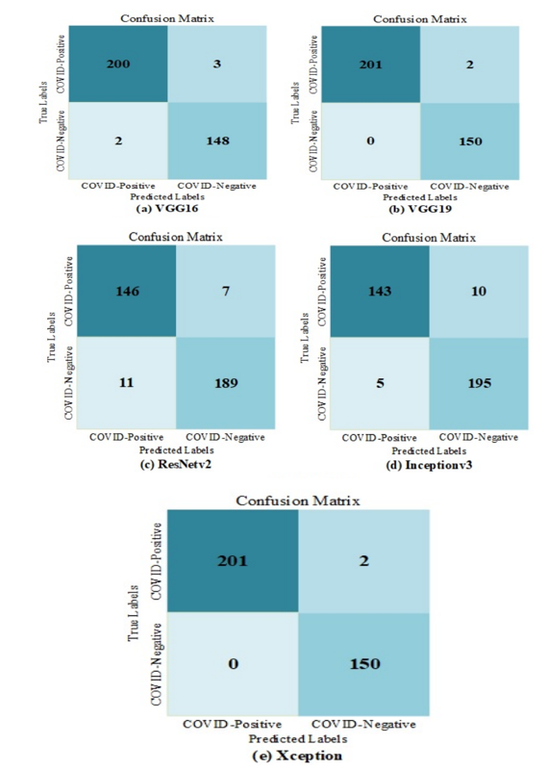

**Fig. 4** Confusion matrix of all deep learning models on test data.

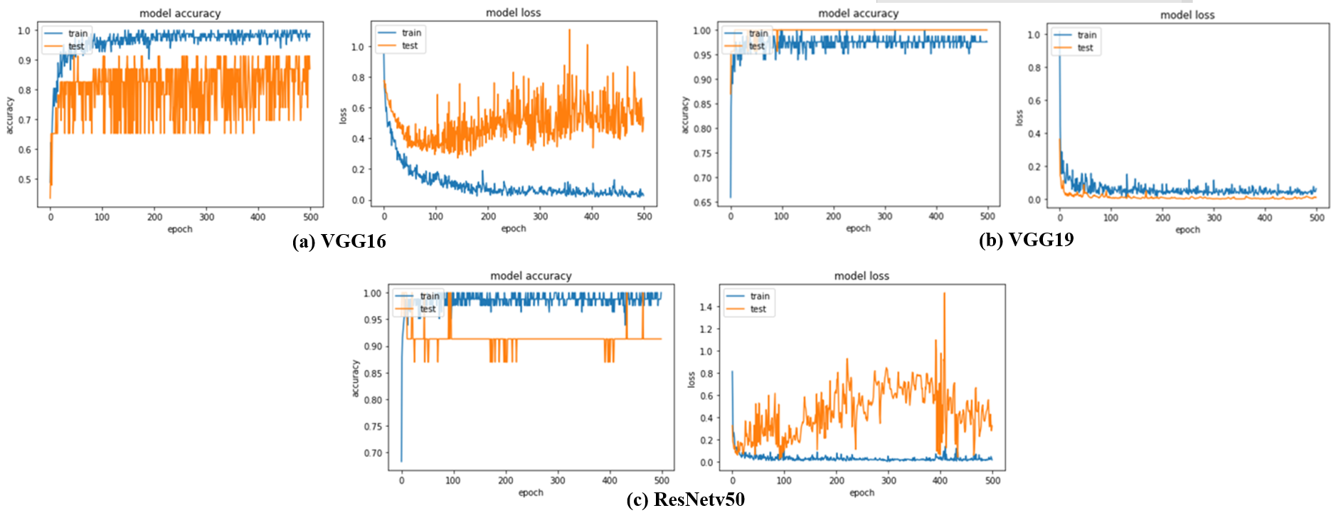

**Fig 5.** Accuracy and loss curves for VGG16, VGG19 and ResNetv50.

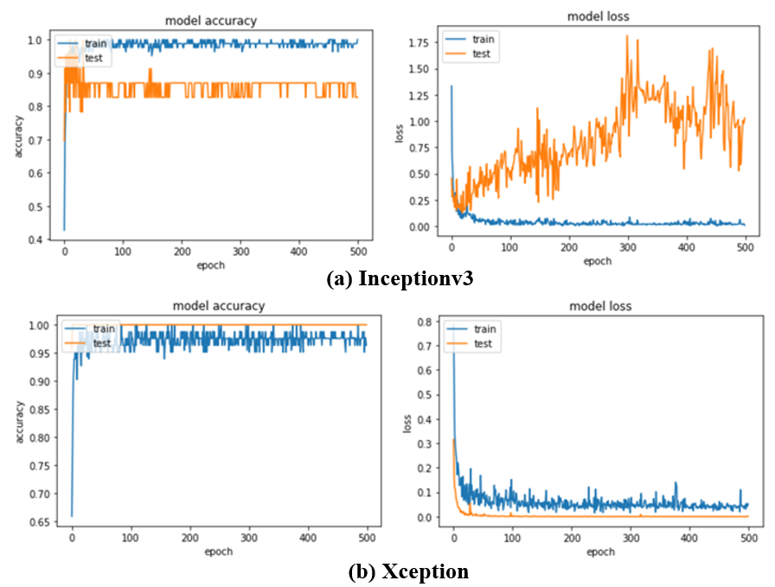

**Fig 6.** Accuracy and loss curves for Inceptionv3 and Xception.

**Conclusion and Future work**

The drastic increment in the number of patients affected with COVID-19 and its worldwide spread demands an efficient diagnosis and testing to overcome the pandemic. Early-stage diagnosis of this virus will help people with fast recovery and slow down the process of spreading. Computed tomography (CT) when integrated with an advance machine learning approaches can produce good results with considerable accuracy thus eradicating the cost and need of extensive medical staff. In this paper we have used transfer learning approach with two categories of X-ray images named COVID-19 negative and COVID-19 positive. The transfer learning provides superior response in terms of precision, sensitivity and F1 score. In the future work authors are used transfer learning of deep CNN model approach with a larger benchmark training as well as testing dataset.